Reporting No:5 Week No:5 From :10/06/2024 To :14/06/2024 College ID: 22IT116

Project Title:

**WEEKLY REPORT**

**Work done in last week ( Attach supporting Documents):**

1. 10/06/2024 Monday

* 9.30am to 11.30 am: Create Breadcrum and add CSS styling in it.

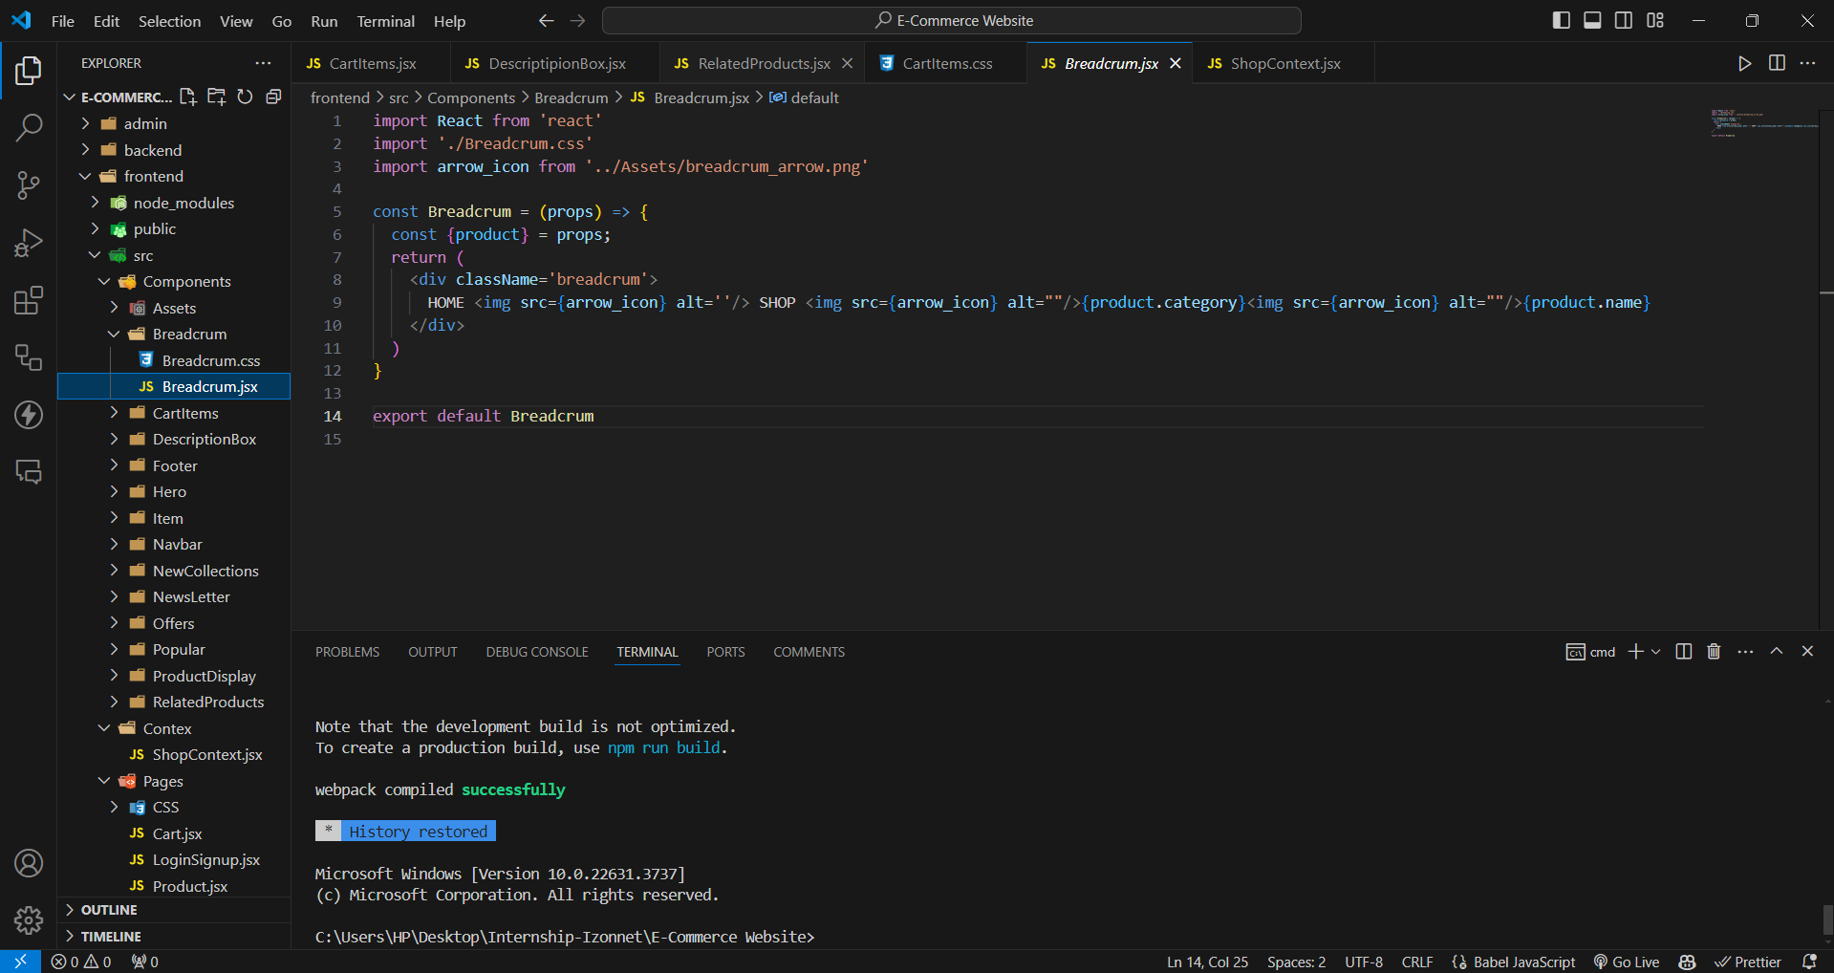

* 12.00pm to 2.30 pm: Create cart item For the Website

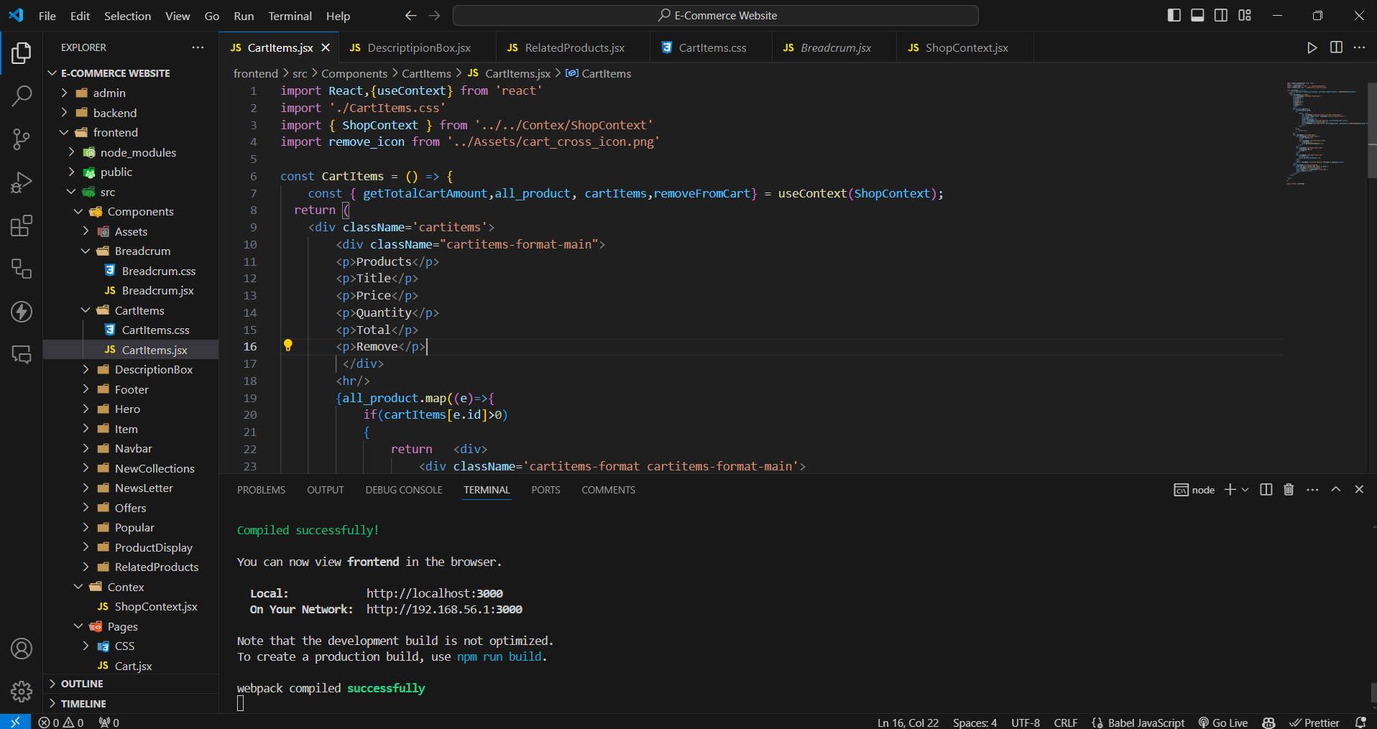

* 3.00 pm to 5.00 pm: Create Shop Context for the website

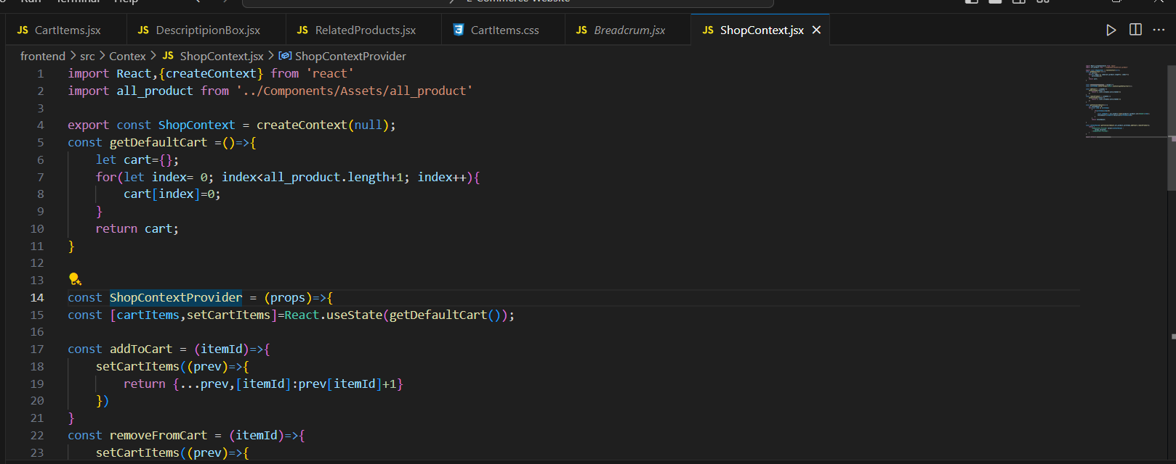

1. 11/06/2024 Tuesday

* 9.30am to 11.30 am: Create Product Display page for Website and add CSS styling.

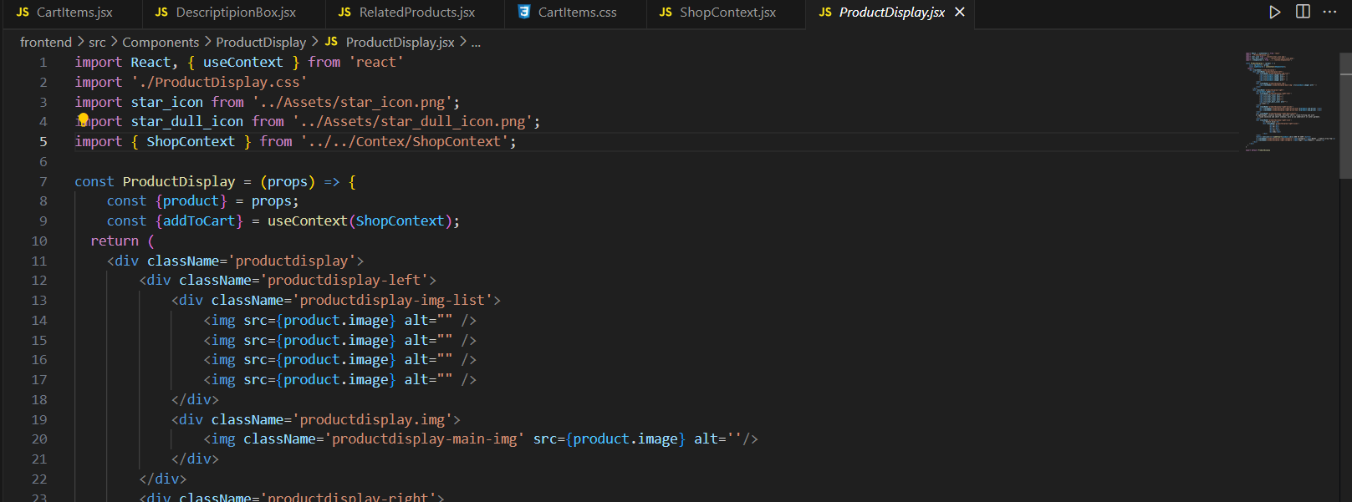

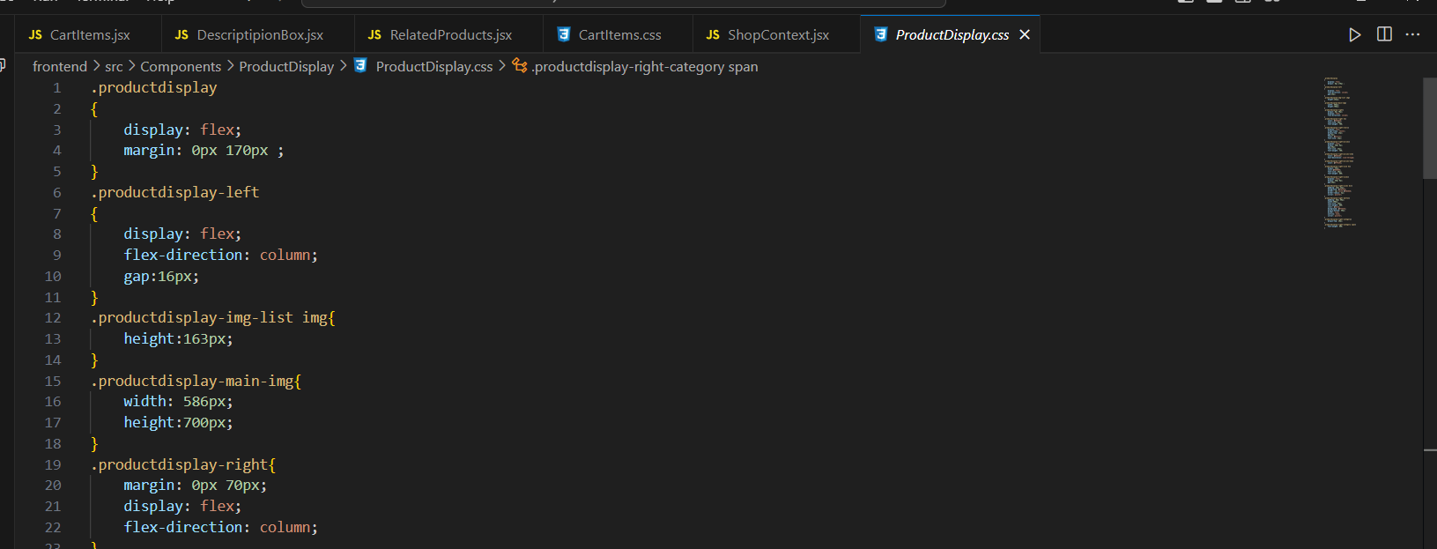

* 12.00pm to 2.30 pm: Create Related Product components and add CSS styling

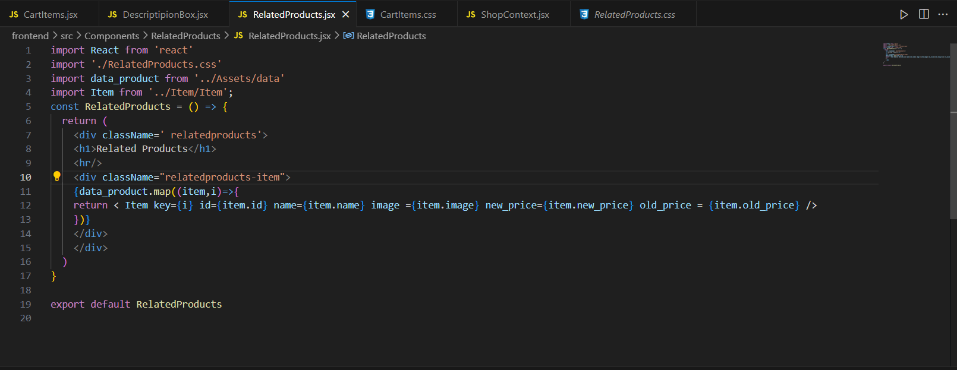

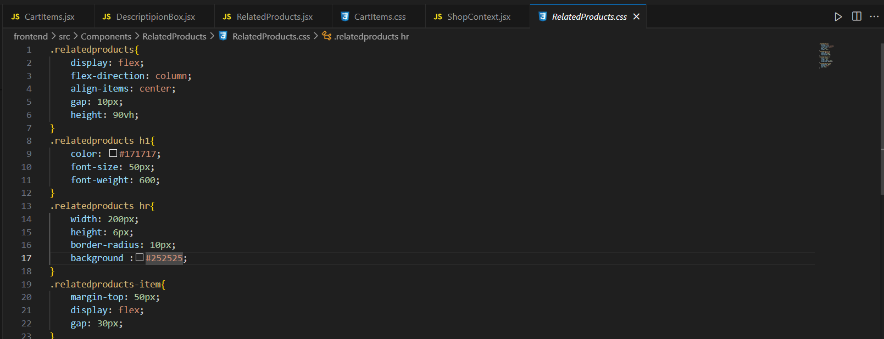

* 3.00 pm to 5.00 pm: Create a Description box for the website and add CSS styling

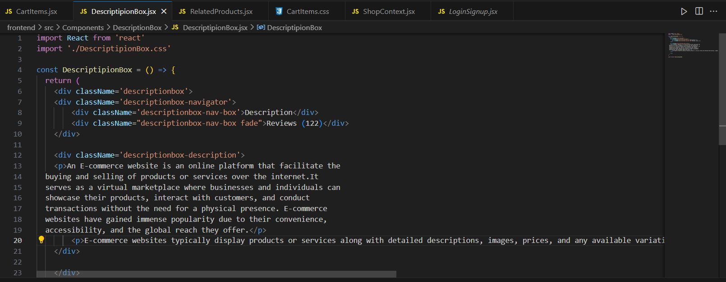

1. 12/06/2024 Wednesday

* 9.30 am to 11.30 am: Create Admin for the website and add Product component

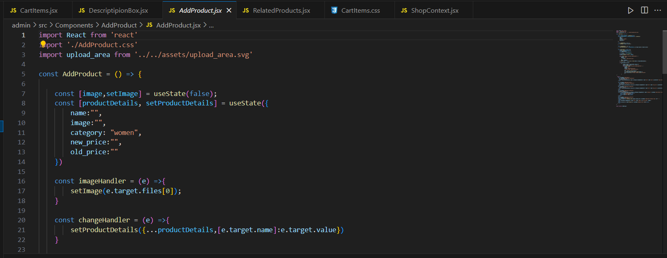

* 12.00pm to 2.30 pm: Create a Navigation bar and sidebar for the admin.

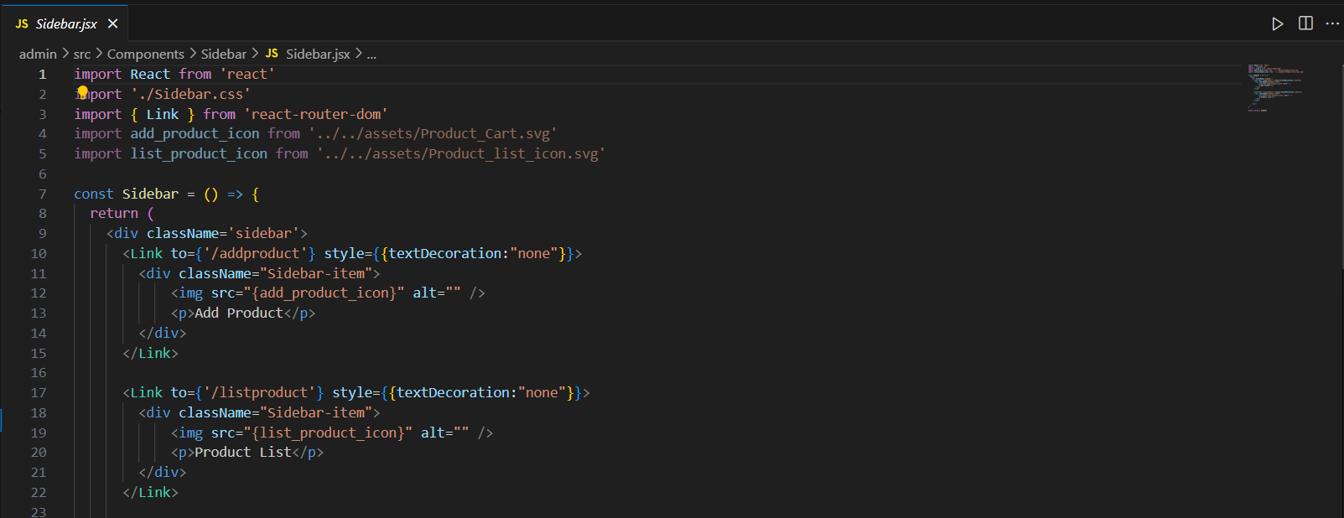

* 3.00 pm to 5.00 pm: Create Product List for the Admin

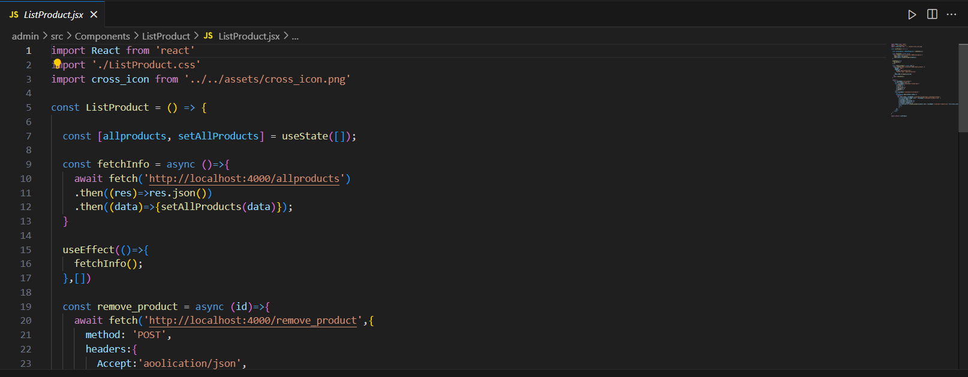

1. 13/06/2024 Thursday

* 9.30 am to 11.30 am: Connect Backend with MongoDB
* 12.00pm to 2.30 pm: Create Image store engine and uploading endpoint for images

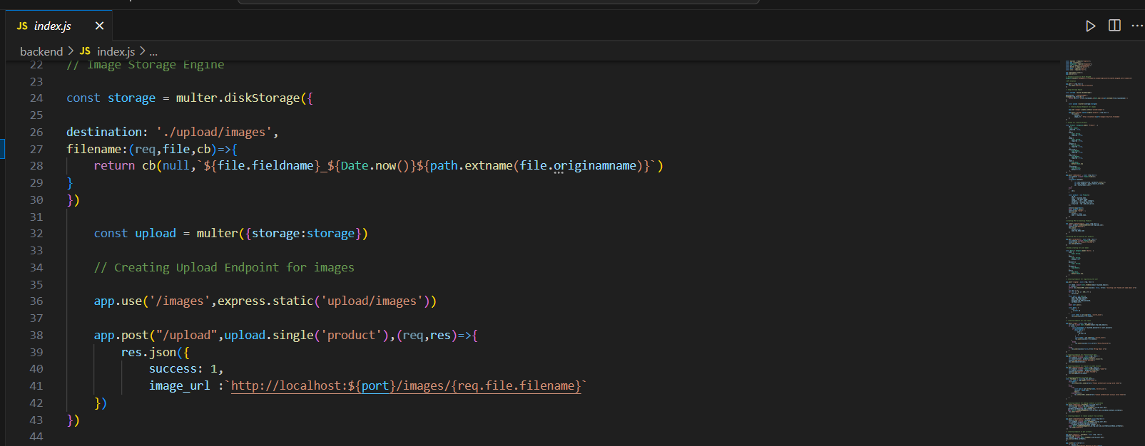

* 3.00pm to 5.00 pm: Create Schema for Product and user model.

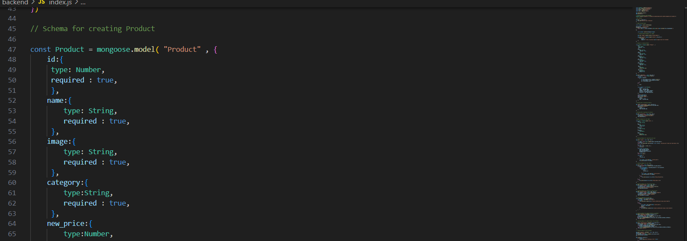

1. 14/06/2024 Friday

* 9.30 am to 11.30 am: Create a API for add product

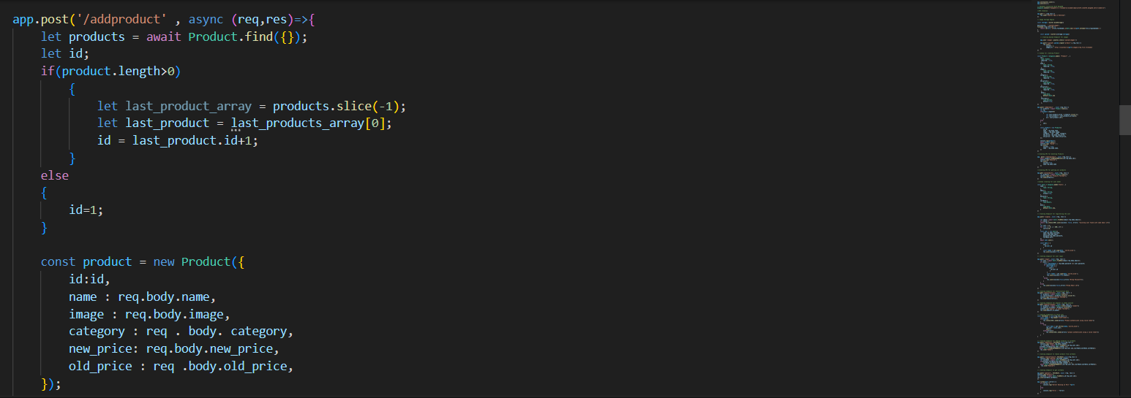

* 12.00pm to 2.30 pm: Create a backend part for login, section fetch data etc.

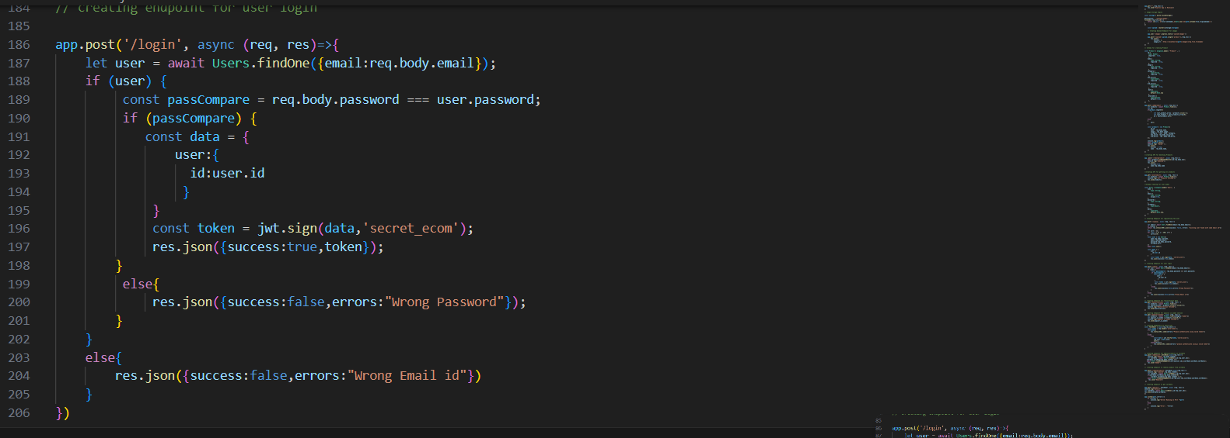

* 3.00pm to 5.00 pm: Create a backend for Cart.

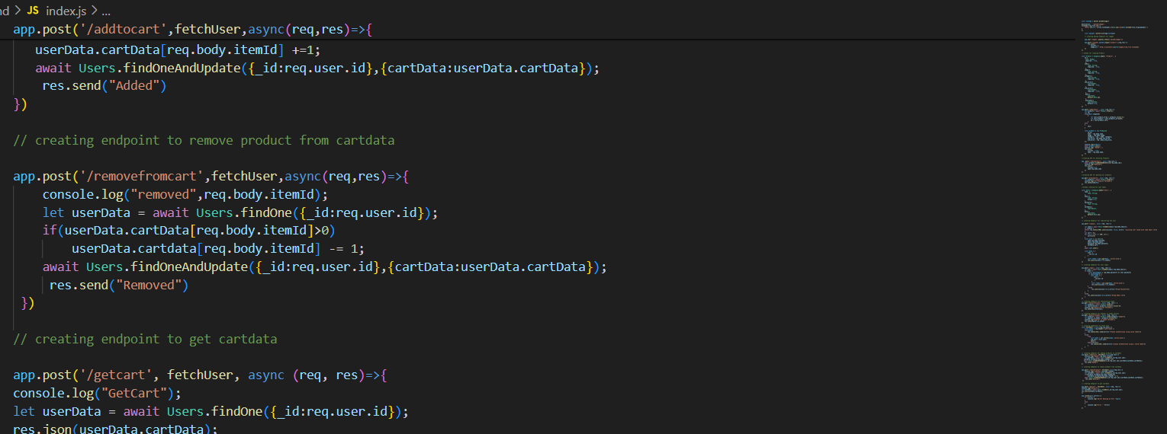

**References:**

1. YouTube Channel: [Thapa Technical](https://www.youtube.com/@ThapaTechnical)
2. React Documentation
3. Express Documentation
4. Node Documentation
5. MongoDB Documentation

**Signature of External Guide Signature of Internal Guide**

Student Id: 22IT116

Student Name: TRUSHANGKUMAR SUMANBHAI PATEL